**CS 155 Project 1 Image Processing**

Xiaotian Wang & Ziqi Xiong

1. Filter implemented

|  |  |  |
| --- | --- | --- |
| **Simple pixel transformations** | | |
| **If Completed** | **Function Name** | **Points** |
| Y | Color Shift | 3 |
| Y | Extract Channel | 3 |
| Y | Grey | 3 |
| Y | Sepia tone | 3 |
| Y | Threshold | 3 |
|  |  |  |
| **Interpolation/Extrapolation** | | |
| Y | Interpolation/extrapolation | 5 |
| Y | Brighten | 3 |
| Y | Contrast | 3 |
| Y | Saturation | 3 |
| Y | Invert | 3 |
|  |  |  |
| **Convolution** | | |
| Y | Convolve | 5 |
| Y | Edge detect | 3 |
| Y | Blur by Box filter | 3 |
| Y | Blur by Gaussian filter | 3 |
|  |  |  |
| **Quantize** | | |
| Y | Quantize by rounding | 0 |
| Y | Quantize by ordered dithering | 10 |
| Y | Quantize by Floyd-Steinberg error-diffusion dithering | 10 |
|  |  |  |
| **Warp** | | |
| Y | Nearest neighbor | 1 |
| Y | Bilinear | 4 |
| Y | Gaussian | 5 |
| Y | Rotate | 5 |
| Y | Scale | 5 |
| Y | Fun Warp | 5 |
|  |  |  |
| **Misc. effects** | | |
| Y | Composite | 5 |
| Y | Image Shift | 3 |
| Y | Crop | 5 |
| Y | Median filter | 5 |
| N | Bilateral filter | 10 |
| N | Sobel operator | 5 |
| Y | Nonphotorealism | ? |
|  |  |  |
| **Create an image/movie** | | |
| In Progress | Image 1 | 5 |
| In Progress | Image 2 | 2 |
| In Progress | Movie 1 | ? |

1. Test cases
2. Color Shift

Input parameter: None

Input: Output:

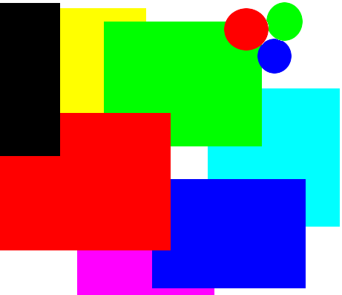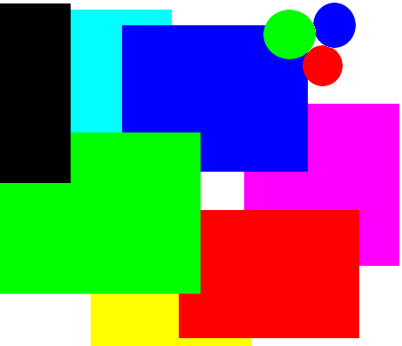

1. Extract Channel

Input parameter: 0

Same input; Output:



1. Grey

Input parameter: None

Input: Output:

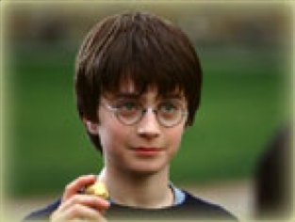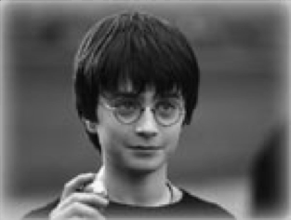

1. Sepia tone

Input parameter: None

Same input; Output:

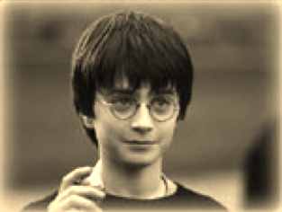

1. Threshold

Input parameter: 0.3

Same input; Output:

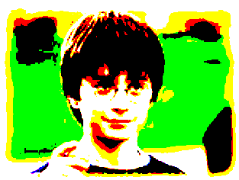

1. Interpolation/extrapolation

Input parameter: grey.bmp, factor: 0.7

Same input; Output:

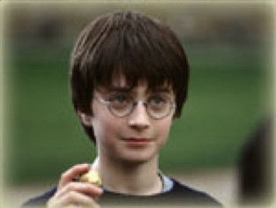

1. Brighten

Input parameter: 1.4

Same input; Output:

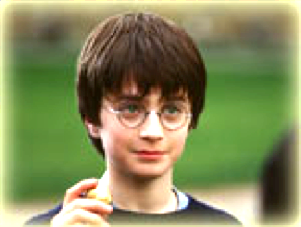

1. Contrast

Input parameter: 0.6

Same input; Output:

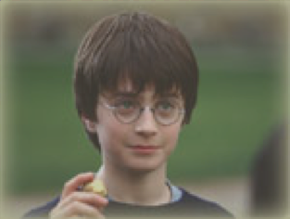

1. Saturation

Input parameter: 1.6

Same input; Output:

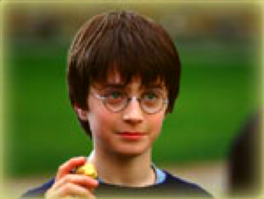

1. Invert

Input parameter: None

Same input; Output:

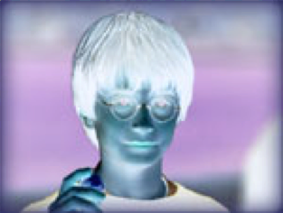

1. Convolve

Input parameter: kernel.txt

Same input; Output:

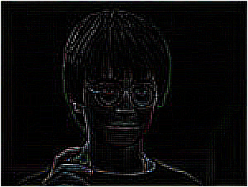

1. Edge detect

Input parameter: None

Same input; Output:



1. Blur by Box filter

Input parameter: 5

Same input; Output:

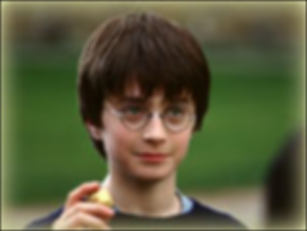

1. Blur by Gaussian filter

Input parameter: size 9, factor 4

Same input; Output:

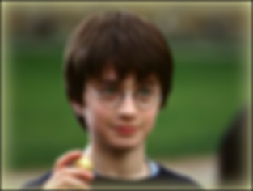

1. Quantize by rounding

Input parameter: 2

Same input; Output:

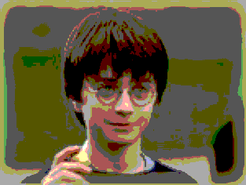

1. Quantize by ordered dithering

Input parameter: 2

Same input; Output:

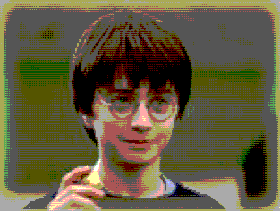

1. Quantize by Floyd-Steinberg error-diffusion dithering

Input parameter: 2

Same input; Output:

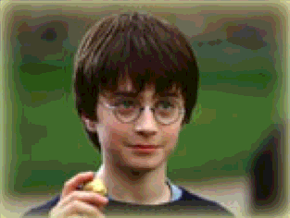

1. Nearest neighbor

Input parameter: degree 30, x: 156, y:117

Same input; Output:

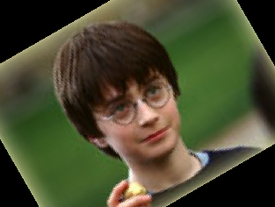

1. Bilinear

Input parameter: degree 30, x: 0, y: 0

Same input; Output:

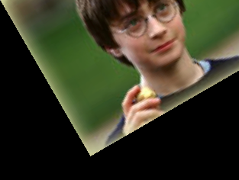

1. Gaussian

Input parameter: degree 30, x: 156, y:117

Same input; Output:

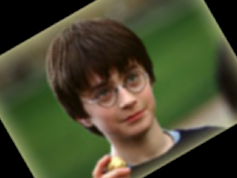

1. Rotate

Input parameter: degree 30, x: 156, y:117

Same input; Output:



1. Scale

Input parameter: x:2, y: 1

Same input; Output:

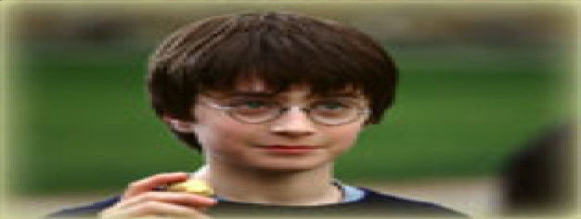

1. Fun Warp

Input parameter: 250, 117, 150, 10, 6.5, 1.5, 1, 1

**Smaller than width, smaller than height, larger than 1, larger than 1, larger than 1, larger than 1, 1, 1**

Same input; Output:

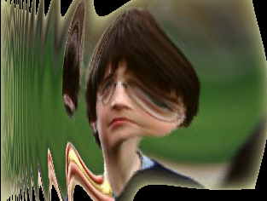

1. Composite

Input parameter: harry.bmp, Gaussian_r.bmp, Gaussian_r.bmp

Same input; Output:



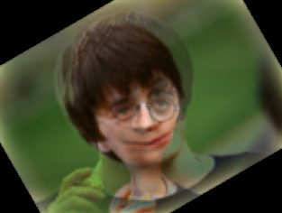

1. Image Shift

Input parameter: x: 50, y: 120

Same input; Output:

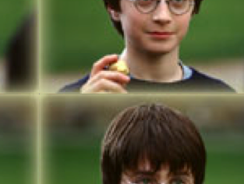

1. Crop

Input parameter: 60, 20, 220, 200

Same input; Output:

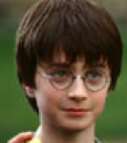

1. Median filter

Input parameter: 3

Same input; Output:

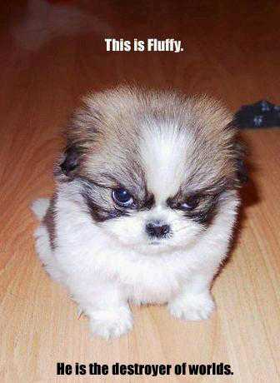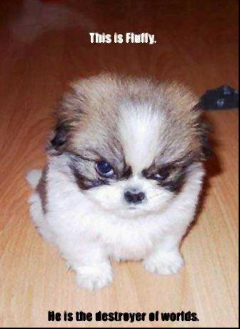

1. Bilateral filter

Not implemented.

1. Sobel operator

Not implemented.

1. Nonphotorealism

Input parameter: wind level: 6 (**level >= 2**)

Same input; Output:

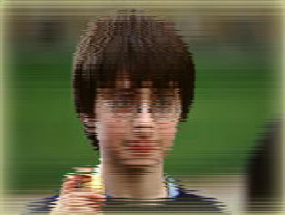

1. Known bugs

There are no known bugs.